ANNOUNCEMENT
LIU Huixian Earthquake Engineering Scholarship Awards in 2019
The Huixian Earthquake Engineering Foundation (China) and the US-China Earthquake Engineering Foundation (USA) are pleased to announce that about ten (10) LIU Huixian Earthquake Engineering Scholarship Awards are available in 2019. Applicants must currently be enrolled as a full-time master’s degree or doctoral degree student in earthquake engineering or a closely related field. Applicants must be at a university or research institute in China, USA, Singapore, or a member center of the Asian-Pacific Network of Centers for Earthquake Engineering Research (ANCER).
Application materials should be submitted electronically to the Secretariat of the Huixian Earthquake Engineering Foundation by June 30, 2019.
http://www.hxeef.cn/ -- Huixian Earthquake Engineering Foundation.
http://www.iem.ac.cn/-- Institute of Engineering Mechanics, China Earthquake Administration (IEM, CEA).
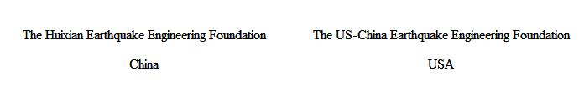
Contact Information:
LI Tianning Tel.: +86-15765535350
WANG Chunjiao Tel.: +86-451-86652832; +86-18145196185
Secretariat of Huixian Earthquake Engineering Foundation
Add: 29 Xuefu Road, Harbin 150080, China
E-mail: hxeef@iem.cn
Web: http://www.hxeef.cn/

Attachment 1: LIU Huixian Earthquake Engineering Scholarship Award: Description and Guidelines
Attachment 2: Application Form for the LIU Huixian Earthquake
Engineering Scholarship Award

